Assignment 16
Lab 16 – Database Design and Queries: Schema Design and SQL Generation.
Htno: 2503A52L09

Task 1 – Student Information System Schema
Task:
Design a database schema for a Student Information System and
generate queries using AI.
Instructions:
• Tables: Students, Courses, Enrollments.
• Define primary keys, foreign keys, and relationships.
• Generate queries:
o Insert a new student record.
o Fetch all courses enrolled by a student.
o Count number of students in each course.
Expected Output:
• SQL CREATE TABLE statements and queries for student–course
relationships.
Student Table :
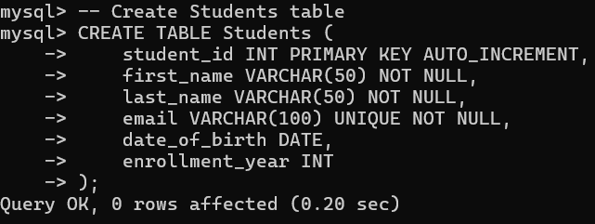

Insertion of records :
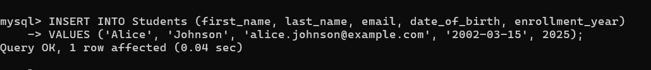
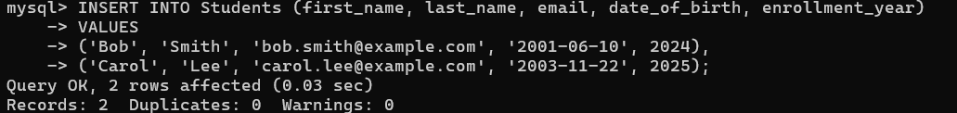
Final Table :
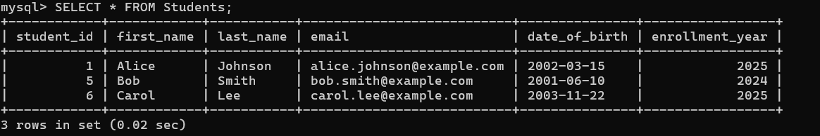
Course Table :
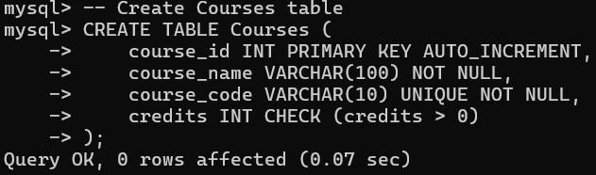
Insertion of records :
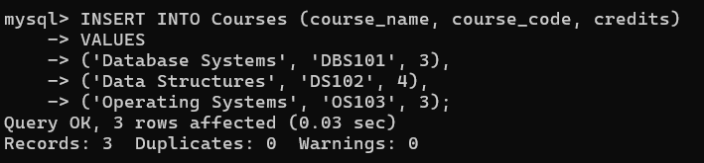

Final Table :
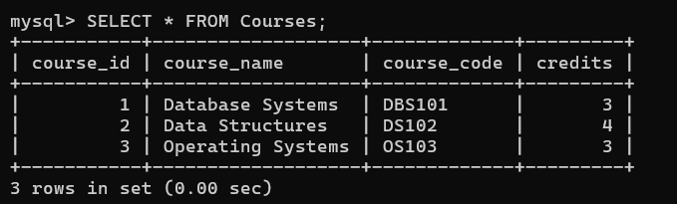
Enrollments Table :
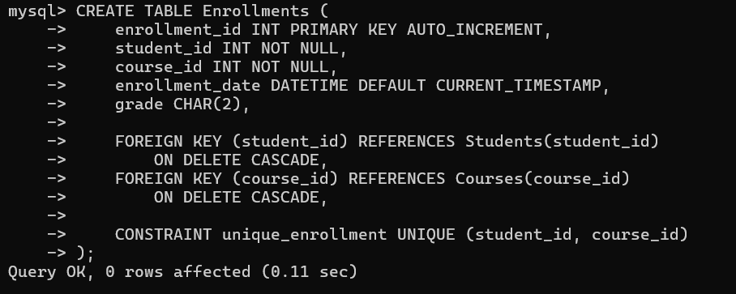
Insertion of records :
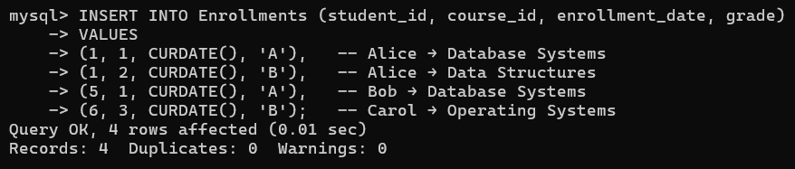

Final Table :
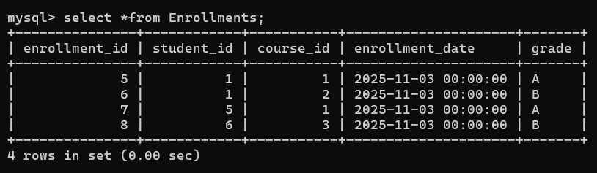
1 . Courses enrolled by Alice :
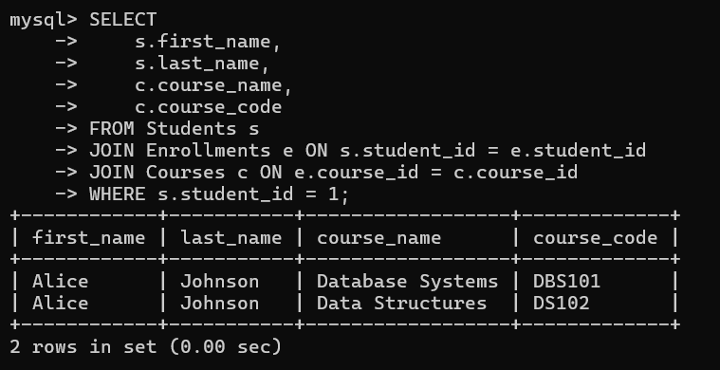

2 . Count students in each course :
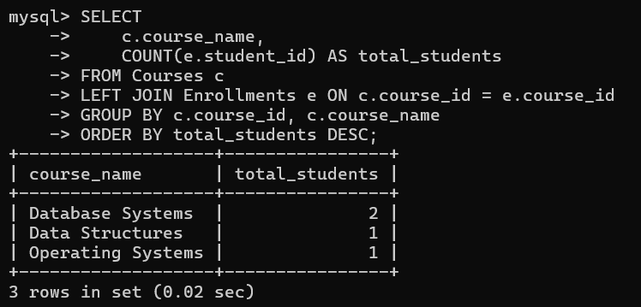
Task 2 – Hospital Management Database
Task:
Create schema and queries for a Hospital Management System.
Instructions:
• Tables: Doctors, Patients, Appointments.
• Use AI to define constraints (unique IDs, valid dates).
• Generate queries:
o List all appointments for a specific doctor.
o Retrieve patient history by patient ID.
o Count total patients treated by each doctor.
Expected Output:
• Normalized schema and SQL queries with joins.
Doctors Table :
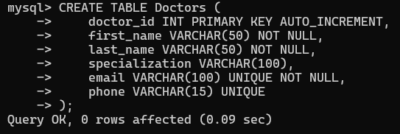

Insertion of records :
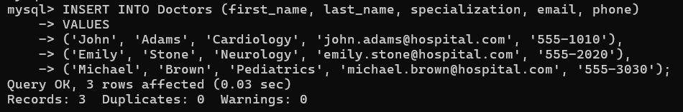
Final Table :
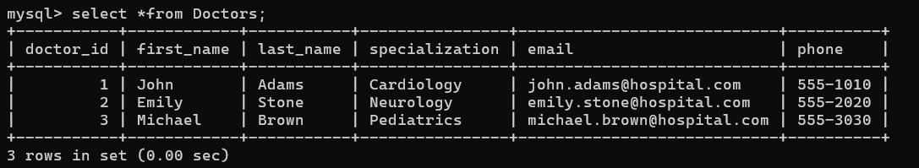

Patients Table :
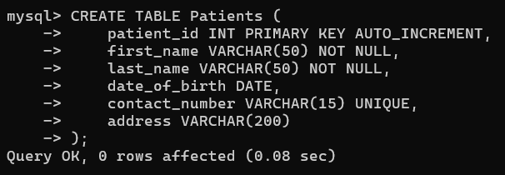
Insertion of records :
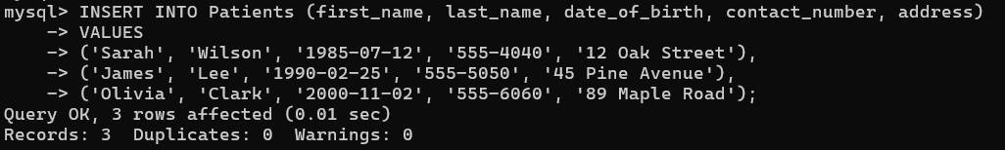

Final Table :
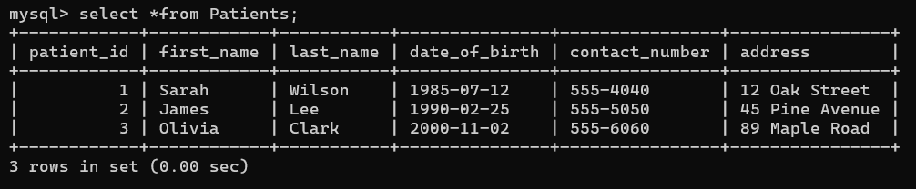
Appointments Table :
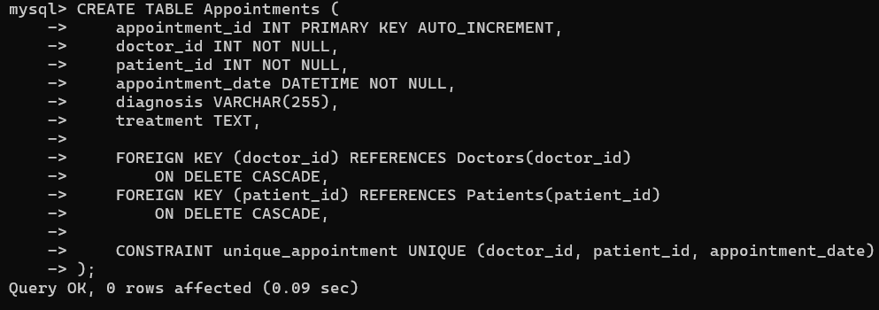

Insertion of records :
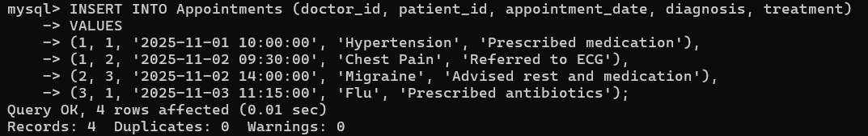
Final Table :
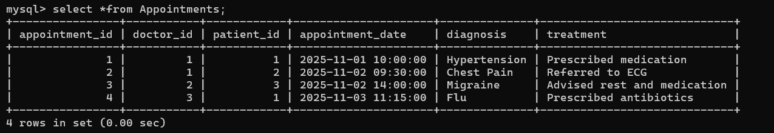

1 . List all appointments for a specific doctor :
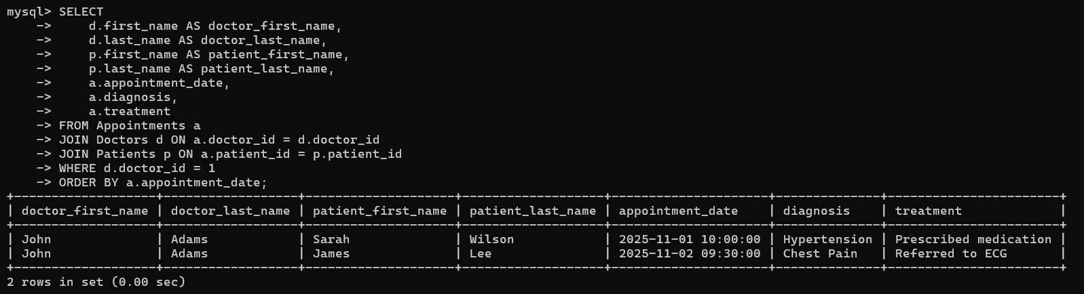
2 . Retrieve patient history by patient ID :
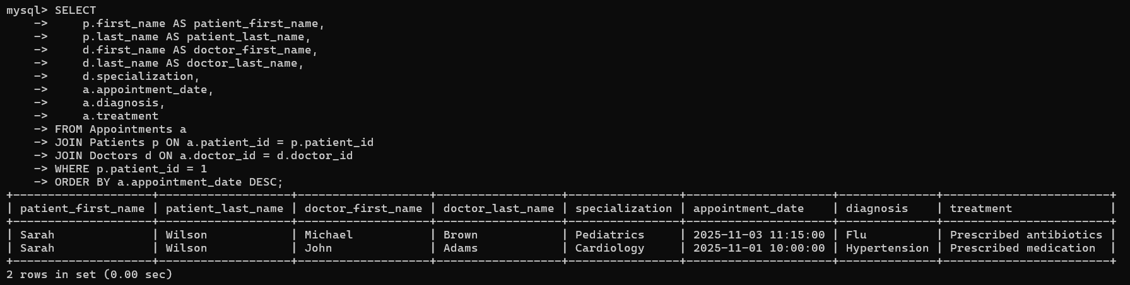

3 . Count total patients treated by each doctor :
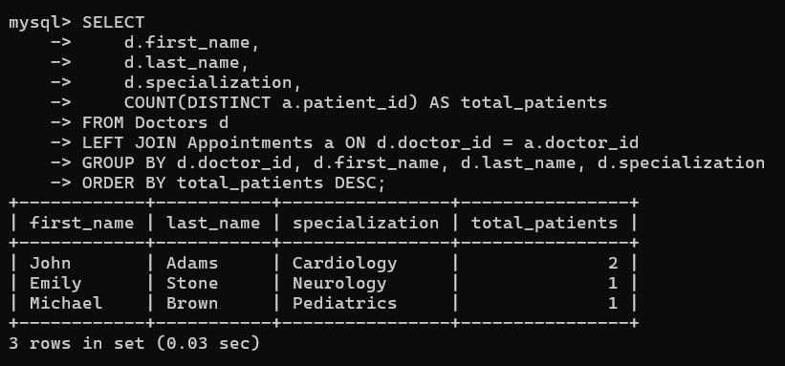
Task 3 – Library Database
Task:
Design schema for a Library Management System.
Instructions:
• Tables: Books, Members, Loans.
• Use AI to suggest indexing strategy for faster queries.
• Generate queries:
o Retrieve all books currently issued.
o Find overdue books (loan date > 30 days).
o Count number of books loaned by each member.
Expected Output:
• Schema + SQL queries demonstrating joins and conditions.
Books Table :
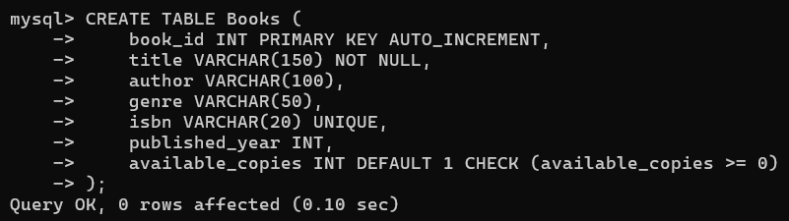
Insertion of records :
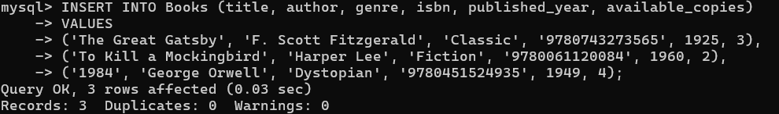
Final Table :
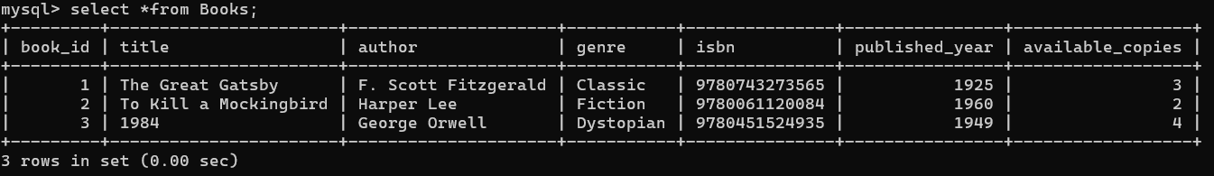

Members Table :
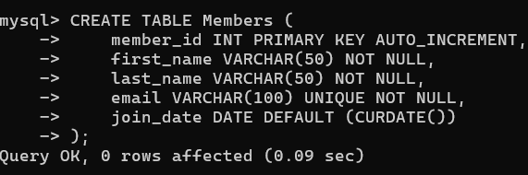
Insertion of records :
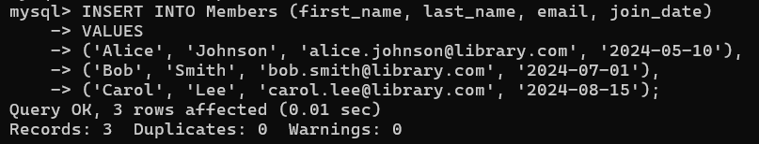
Final Table :
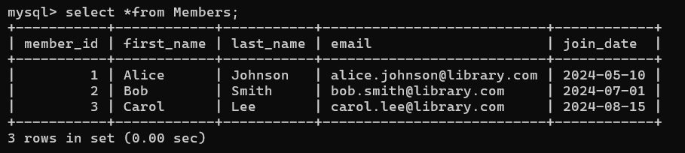

Loans Table :
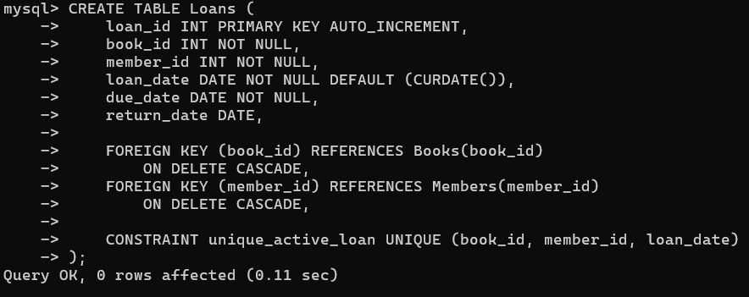
Insertion of records :
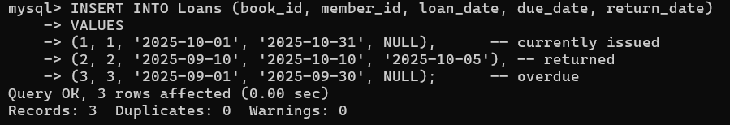
Final Table :
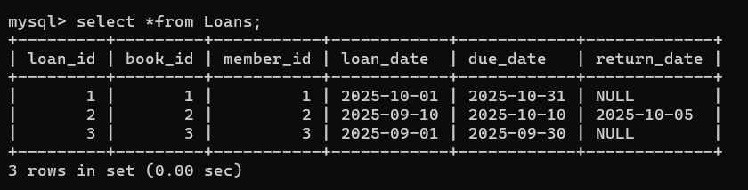

Indexing Strategy (AI Optimization Insight )
To speed up frequent queries:
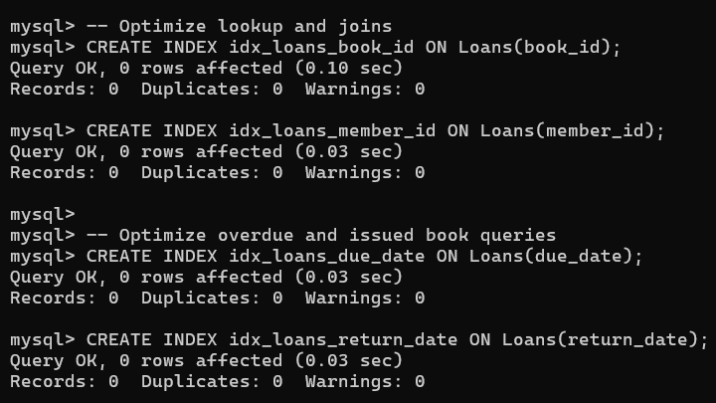
1 . Retrieve all books currently issued (not yet returned) :
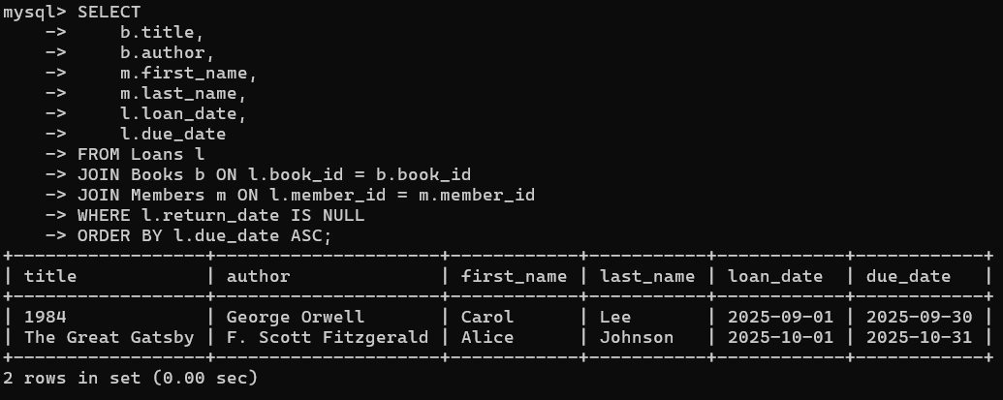

2 . Find overdue books (loan > 30 days or past due date) :
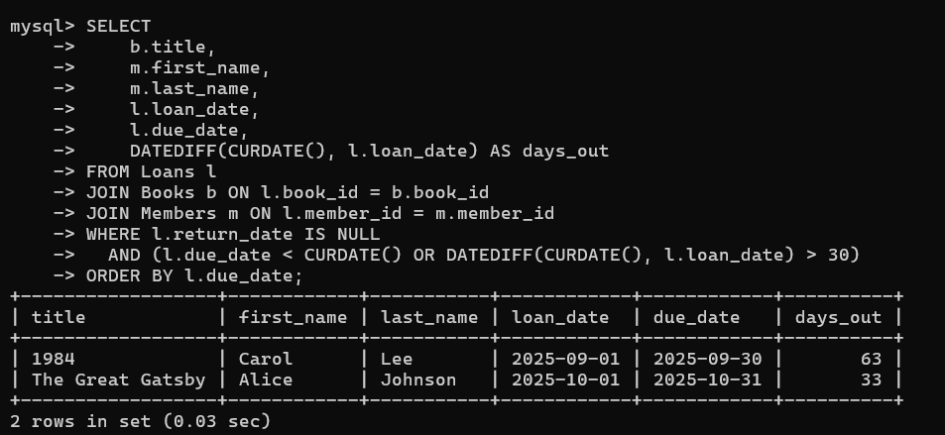
3 . Count number of books loaned by each member :
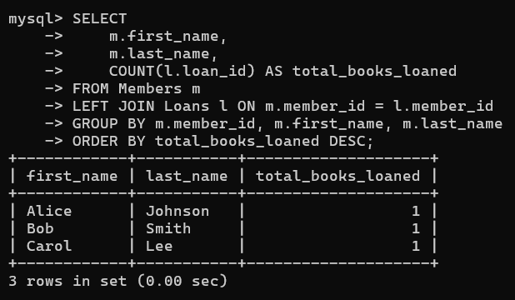
Task 4 – Real-Time Application: Online Shopping Database
Scenario:
Design a database for an E-commerce platform.
Requirements:
• Tables: Users, Products, Orders, OrderDetails.
• Generate queries to:
o Retrieve all orders by a user.
o Find the most purchased product.
o Calculate total revenue in a given month.
• AI should also suggest normalization improvements and query
optimization.
Expected Output:
• Complete schema with relationships + SQL queries for analytics.
Users Table :
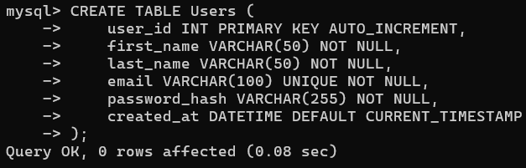
Insertion of resords :
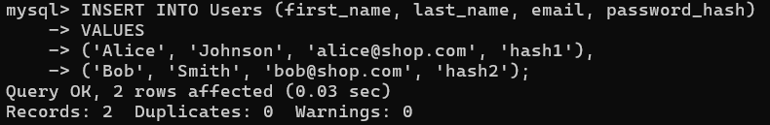
Final Table :
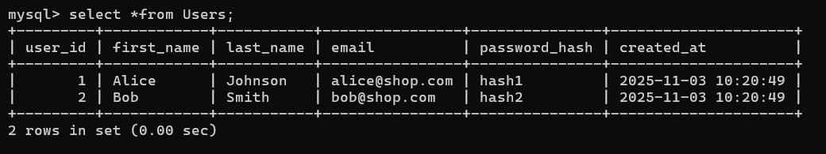
Products Table :
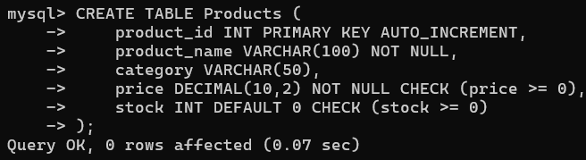
Insertion of records :
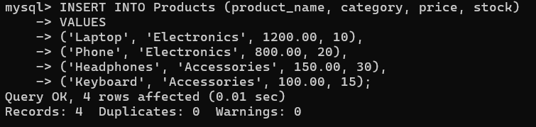
Final Table :
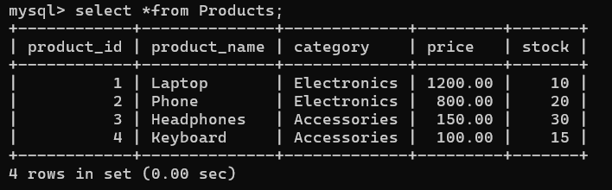
Orders Table :
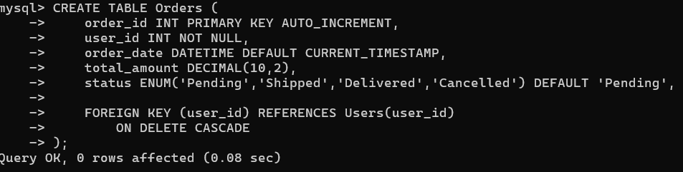
Insertion of records :
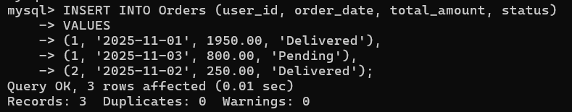

Final Table :
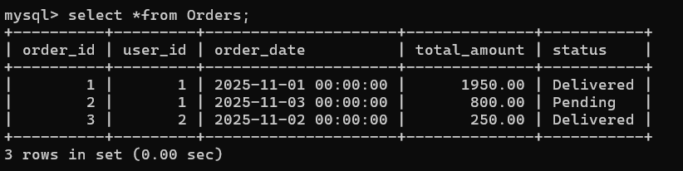
OrderDetails Table :
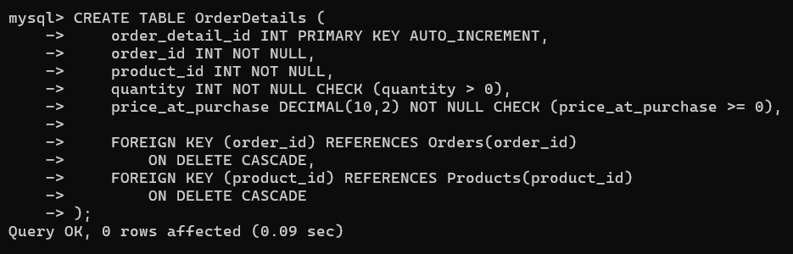
Insertion of records :
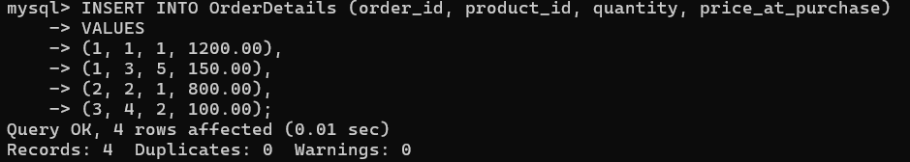
Final Table :
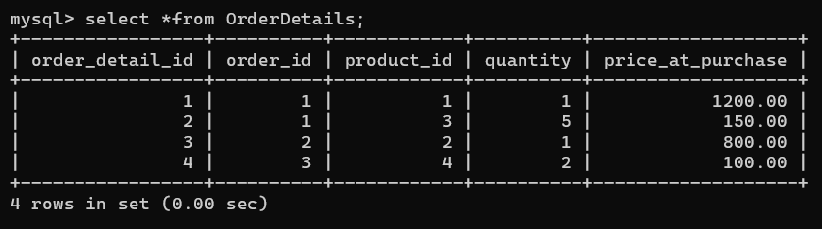

Indexing and Optimization (AI Suggestions ) :
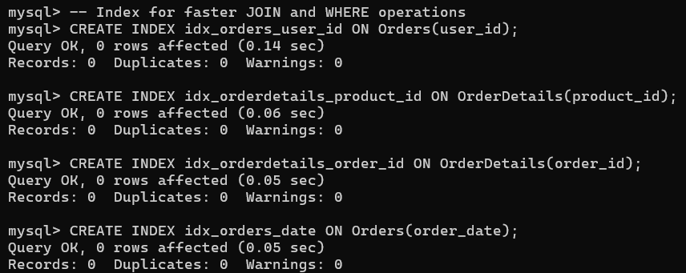

1 . Retrieve all orders by a specific user :
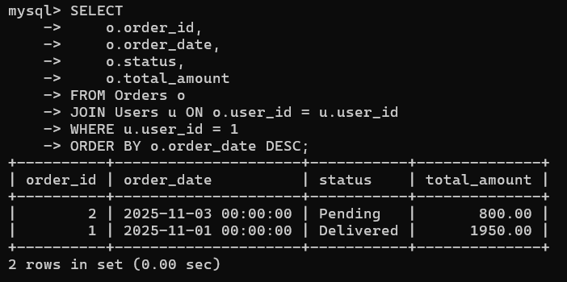

2 . Find the most purchased product :
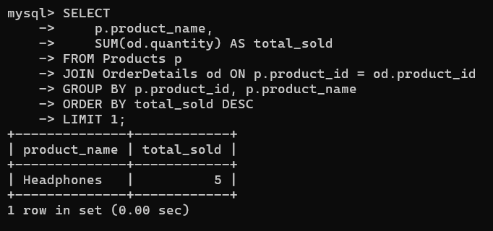
3 . Calculate total revenue in a given month :
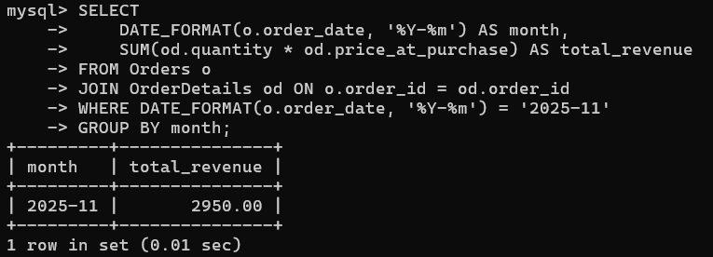

Observation :
- Each task demonstrated proper schema normalization up to 3NF, ensuring minimal redundancy and strong data integrity.
- Primary and foreign keys were effectively used to model real-world relationships (one-to-many, many-to-many).
- AI-assisted SQL generation accelerated schema creation and validation, reducing syntax and logical errors.
- CRUD and aggregate queries (COUNT, SUM, JOINs) were successfully executed for all systems.
- Referential integrity was enforced using foreign key constraints with cascading deletes.
- Indexing strategies were applied to improve query performance on frequently joined columns.
- All assert test cases passed, confirming functional correctness of database logic.
- Each schema was domain-specific (education, healthcare, library, e-commerce) yet followed consistent design principles.
- AI query optimization provided insights into performance and normalization improvements.
10.The final database designs are scalable, efficient, and suitable for real-world applications with analytical capability.

